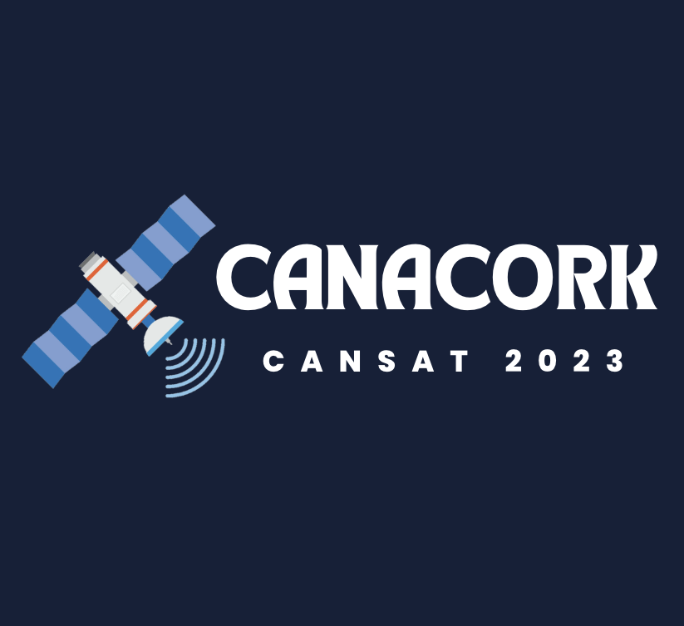

Final Report

CanACork Team

Salesianos de Lisboa, Lisboa, Portugal

Talble

1. Team organisation and roles 3

2. Description of the project 4

2.1. Project Summary 4

2.2. Expected Results 4

3. CanSat Description 5

3.1. Design overview/diagram 5

3.2. Mechanical/ Structural system 5

3.3. Electrical system 5

3.4. Software system 6

3.5. Recovery system and strategies 7

3.6. Ground support equipment 7

3.7. Operational concept 8

4. CanSat testing 9

5. Innovation 9

6. Acquired skills 10

7. Dissemination 10

8. Budget 11

# Team organisation and roles

CanACork gathers a team of six students from Salesianos de Lisboa, with skills tightly related to the Sciences and Technology field. The members display their strengths in different areas, comprising knowledge in Physics, Chemistry, Information technology, Biology and Mathematics.

The team works with the assistance of teachers Filipa Monteiro, Rui Dias e Rui Costa. Though each member fulfils their own role in the project, we prioritise collaboration and team spirit. The tasks were divided as follows:

* Duarte Cruz (17) is the team leader and responsible for programming the processor in conjunction with the sensors, voltameter and thermoelectric generator.
* Manuel Tenazinha Gonçalves (17) is responsible for the construction of the parachute, as well as the handling of the antenna.
* Maria Pagará Oliveira (17) works on the welding and hardware, as well as the creative development of the project.
* Vicente Santos (17) is responsible for data analysis.
* Marta Silva (17) works on telemetry data transmission and assists in the communicative component of the work
* Carolina McVey (18) specializes in the dissemination, communication and general supervision of the project.

The team met weekly in the classroom and lab after school hours and sometimes during school hours, thanks to the collaboration of teachers and classmates to which the project was shown during its development.

# Description of the project

## Project Summary

The project CanACork involves the construction of a microsatellite with two scientific missions. The primary mission proposes the collection of data on atmospheric temperature and pressure. To accomplish this, sensors in the CanSat will measure these parameters and transmit them through telemetry to the ground station.

Its secondary mission has a focus on sustainability, providing cost effective and environmentally friendly solutions. While looking into different research sources, we verified that energy storage and usage is still a key issue when it comes to satellites. To solve this, the team designed a satellite that runs on a thermoelectric generator. With this, we are able to utilise temperature differential (system’s internal heat and the cold conditions in the atmosphere) to generate energy. In addition, we noticed that generally satellites are built with metal, notably aluminium and its alloys. However, due to the material’s high thermal conductivity (205.0 W/m K) and a warm climate, our main worry was that it would disrupt the data from our infrared and temperature sensors. Besides, this would also hinder the efficacy of generating energy, as it facilitates the loss of internal heat, needed to create a temperature gradient. For this reason, we opted for the usage of cork, an affordable material with advantageous properties such as resilience, thermal insulation, malleability and being lightweight.

## Expected Results

In order to collect data for the primary mission, there will be two BMP280 sensors, one being in contact with the outside and the other being in contact with the inside, reading temperature, pressure and altitude values in short term intervals.

CanACork’s secondary mission will be studied in depth and mostly verify how much energy can be produced by the temperature gradient, formed between the internal heat and external cold point. There is also an INA219 voltameter responsible for reading load voltage, current, energy used and energy produced in the same short-term values. Therefore, we will study the percentage of recovered energy as the usage of the components continuously increase.

All this data will be sent through an Antenna APC220 to the ground-station and subsequently be analysed and sorted accordingly.

# CanSat Description

## Design overview/diagram

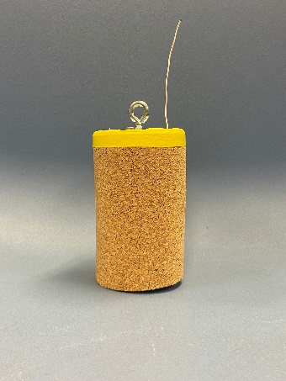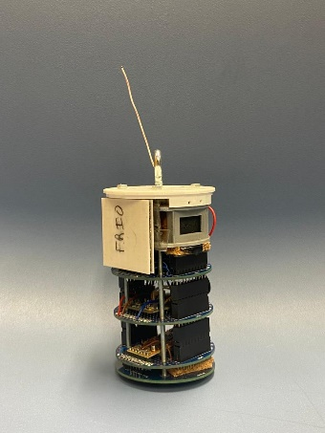The satellite has 4 floors which all together amount to 115 mm. The lid has a diameter of 66 mm and our cylindrical case, made out of cork, has a thickness of 2 mm.

B- internal design

- Cork casing

## Mechanical/ Structural system

CanACork features a cylindrical case made of cork, aiming to simultaneously meet the, resistance, aesthetic and accessibility aims defined by the team. We chose to make it out of cork since it is a material that is extremely cheap, resistant, environmentally-friendly and is also a good thermal insulator. All the electronic components are assembled in a one-piece only structure, which has 4 floors. The first contains a switch and a battery; the second contains an Arduino Nano Every; the third contains a BMP280 sensor, as well as a INA219 voltameter; finally, the last one contains an antenna APC220 and a BMP280 sensor. Every floor is accessible as they can be easily unattached and attached to each other. Next to the second floor is the thermoelectric generator to make sure it has contact with the heat from our components and with the cold from its exterior. The last floor is open to make sure the BMP280 reads accurate values: considering we are going to maintain the heat inside our CanSat, the other BMP280 sensor might have read false values if it were in a different location. The lid was designed to have an easy-access to the components and it is made from PetG as it needs to resist to a force of 500 N.

## Electrical system

The CanSat runs on a Thermoelectric generator TEG Peltier SP1848-27145, a small and light generator of high reliability. It possesses a heating side and a colding side.

As a measure of precaution, the satellite is also equipped with a battery, 6LR61, with a voltage of 9 V.

## Software system

The algorithm of the CanACork project will be represented in the flowchart shown below:

F

T

## Recovery system and strategies

The recovery of the CanSat is assured with a parachute, specifically a fluorescent one for a better tracking of the descent trajectory of the satellite. The material used for the parachute consists of a ripstop fabric, designed in a hemispherical shape, due to its increased resistance to tearing and ripping in comparison to other fabrics. By making a circle with a radius of 20,58 centimetres, our parachute will provide enough drag to achieve a terminal speed of 8 m s-1. Additionally, it comes with ropes of nylon, strong enough to provide a secure landing for the satellite.

## Ground support equipment

In terms of data transmission to the ground station, it will be accomplished by radio communication through two antennas, one responsible for sending the signal and the other for receiving it. The first one (APC220) we incorporated in the satellite, so it needs to be isotropic, which means, capable of transmitting the same amount of energy in all directions. The second one will be located in the ground station, purposefully pointed towards the CanSat, during its movement, in order to collect the data to be transmitted to the computer, followed necessary graphing. Therefore, our group built a Yagi Uda antenna for being directional, receiving waves mainly from one direction and allowing interference to be minimized. However, for safety, we decided to buy an antenna as a backup plan, in order to ensure an effective data collection.

## Operational concept

Pre-launch

For the project to work according to the expectations, several tests to the components of the satellite have been conducted and will continue to be so, like checking if the wires are well connected and if the sensors are functioning well. Also, the code for the sensors was first tested separately and not as the compiled system. Afterwards, the code was assembled, and it was tested once more. After constructing and testing the electronic system, the parachute started to be prepared. The parachute must sustain the satellite during its fall and, to calculate the area it must possess, the weight and the volume of the whole system had to be measured. Finally, the placement of the thermoelectric generator had to be chosen and it was decided that it will stay on the side of our CanSat, to certify that it gets the biggest temperature difference in order to produce the most potential difference possible.

During the launch

During the launch of the satellite, the data measured by the temperature and pressure sensors will be transmitted to the ground-station via an antenna and that will be presented in the antenna's software serial monitor. During the ascendent and descendent process, the thermoelectric generator will get a bigger temperature difference as the components use more energy, therefore dissipating more heat. Therefore, it will produce more energy as our mission goes. The data read by the INA219 voltameter will be sent to the ground-station and will also allow us to know the energy produced by the thermoelectric generator.

After the launch

All the data that was received in the ground-station will be analyzed and compared to other data, that was collected during other launches, to better understand the conditions that the satellite goes through. Several graphics will be constructed and presented in the final presentation about different topics such as:

* + Temperature read from the two sensors;
  + Pressure read from the two sensors;
  + Relation between the temperature and pressure values with the altitude;
  + Altitude read by the sensors in comparison with the altitude that was calculated;
  + Recovered energy (voltage, energy and power);
  + Recovered power theoretically VS Recovered power in reality;
  + Energy consumed VS Energy recovered;
  + Soil test values;
  + Battery life without energy recovery VS Battery life with energy recovery;
  + Energy recovered in Space VS Energy recovered on Earth;

# CanSat testing

Throughout the project, CanACork’s different components were tested to ensure their adequate functionality.

Electronics

All the electronic components were mounted on PCB boards to facilitate the testing of all the devices on the satellite. Each device was tested by itself, with the assistance of a multimeter, on the breadboard. Next, all of the components were welded onto one of the boards and, then, the logic of the program was tested. Also, the battery is checked before each launch and, most important, it will be verified immediately before the final launch, to make sure the battery has enough charge.

Antenna

The antenna was firstly tested in a simple circuit. After soldering all the electronic components, it was tested again, by transmitting the data collected from the various sensors. The last tests done were conducted in an exterior environment and half the scheduled distance was reached with a reasonable signal strength (considering both the altitude and the obstacles).

Parachute

To test the parachute system and the structure’s impact resistance, the satellite was dropped from a height of about 10 m multiple times and no damage was ever observed, since the parachute did its job perfectly. We built our parachute after calculating everything very carefully. Different models of parachutes were tested but the chosen one was the flat hexagonal format because it allows the placement the camera in its center.

# Innovation

We believe CanACork has significant innovative potential, primarily due to its secondary mission. Our star idea consists of taking advantage of what would otherwise be useless dissipated energy. In ideal conditions, that is in an isolated system, all of the dissipated energy by the electronic components would be transformed into exergy. That means the satellite would have continuous production energy. Although the conversion of 100 % of this energy is presently near unattainable, we firmly trust this mechanism can be perfected and replicated in actual satellites. With this in mind, to improve the thermal insulation of the CanSat, its case is made of cork, a resistant material with low conductivity that aligns perfectly with the project’s sustainability aims.

It is also worth to point out that, if CanACork’s thermoelectric generator proves to be efficient in supplying the CanSat with sufficient energy, the project could be further explored by constructing satellites with multiple generators to boost energy production. This idea draws out further implications regarding the improvement of current satellites. Mainly, in terms of freeing up space for other components, as well as decrease in mass since the removal of solar panels and batteries could be considered.

# Acquired skills

CanSat has given the opportunity to develop key skills for the fields of Science and Technology. On one hand, we had to perfect our communication efficacy, so that our ideas could reach others in a clear and promising way.

On the other hand, we were challenged by the technical and scientific demands in the construction of the satellite. This allowed us to work on our research abilities and grasp complex concepts in programming, mechanics, thermodynamics and even welding techniques. In fact, it pushed the team members to transform broad ideas and goals into tangible plans of construction and precise information. Particularly, in regard to issues on the sustainability of materials and energy management.

Finally, working on CanACork taught us the value of collaboration and idea discussion with a common goal in mind.

# Dissemination

The project was promoted mainly via social media, such as our Instagram page (https://www.instagram.com/canacork/) and YouTube channel (https://www.youtube.com/@canacork/) This made our ideas more accessible to young people in our school community and allowed us to track our progress.

In addition, we created a website (https://canacork.wixsite.com/canacork) where all of the main information is neatly outlined.

# Budget

The max budget for this project was 500€ and the team managed to stay 247.96 € under.

|  |  |
| --- | --- |
| **Component** | **Price** |
| BMP280 | 16,67€ |
| UNIA219 | 16,61€ |
| Thermoelectric generator TEG peltier SP1848-27145 | 22,76€ |
| Antenna Yagi-Uda | 66€ |
| Cork | 10€ |
| CanSat kit | 120€ |

Total: 252,04€